WEB AND MOBILE APPLICATIONS PORTFOLIO
“SWEET CAT CAFÉ”
BY MARIIA KLYMENKO
This document outlines the professional development and technical milestones achieved during the 10-week web development course. The project focused on building Sweet Cat Cafe, a luxury-style cat cafe in Prague.

WEEK 01
Foundation & Environment Setup
Setting up the development environment, local servers, and initial WordPress installation on Pantheon.io. Key Achievements: WordPress Installation, Pantheon Dashboard Setup, Understanding CMS Architecture.
WEEK 02
Visual Identity & Concept Design
Defined the "Sweet Cat Cafe" brand persona by implementing a luxury dark-mode aesthetic using the Kadence theme, Playfair Display typography, and a minimalist color palette inspired by Prague’s premium cafe culture.
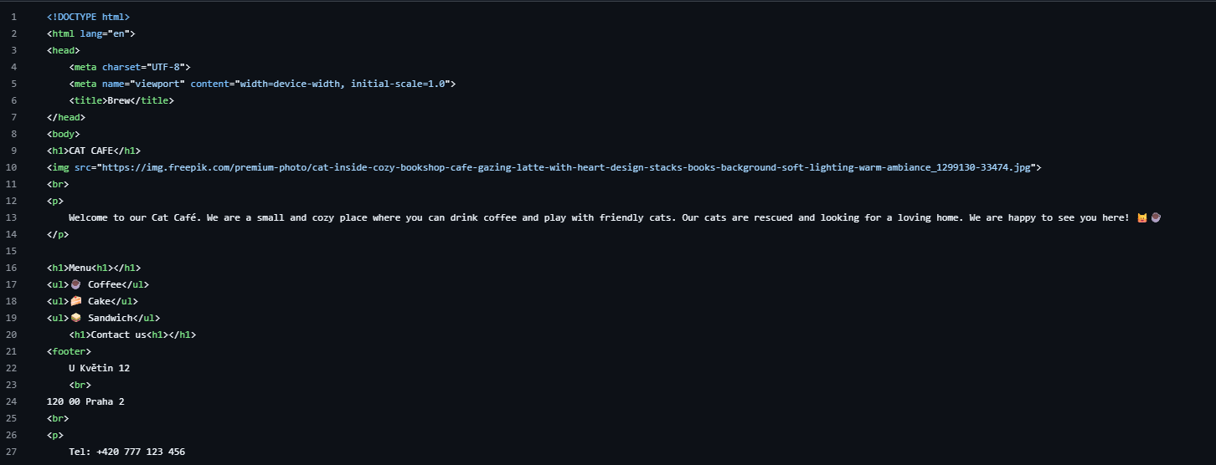

WEEK 03
The Skin (Mobile-First CSS)
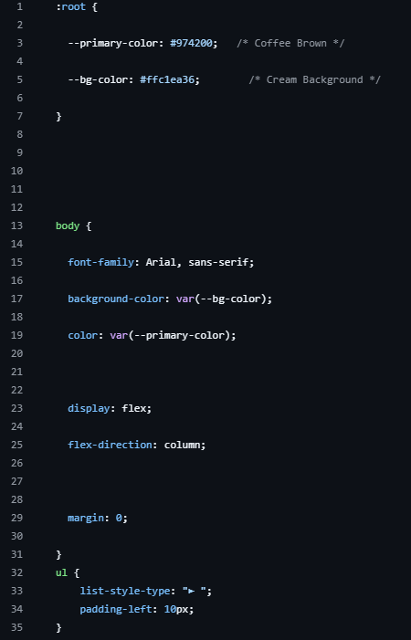
Transformed the site’s HTML skeleton into a branded mobile landing page by implementing an external CSS stylesheet focused on responsive design, flexbox layouts, and custom variables to ensure a flawless "thumb-zone" experience on small screens.

Week 04
The Management Layer (WordPress & Security)
Migrated the project to a live Pantheon environment and established a secure, SEO-optimized foundation by implementing the Wordfence firewall, custom login URLs, and RankMath metadata while building out the initial page architecture.
There are my links
https://dev-sweetcatcoffee.pantheonsite.io/
https://dev-sweetcatcoffee.pantheonsite.io/parara

Week 05
Data Collection, GDPR & Events
Developed a data-driven business infrastructure by integrating Google Tag Manager and GA4 for conversion tracking, while ensuring 100% GDPR compliance through a professional cookie-consent system and visual heatmaps via Microsoft Clarity.
GTM-NB95RQ88 - Google Tag Manager ID
G-RBXLYR8PF9 - Analytics ID
Conversion Description: I am tracking clicks on the menu links (coffee, tea, cakes) to understand which category is most popular.

Week 06
AI-Augmented UI Design
Leveraged Generative AI tools to define a sophisticated brand persona, generate professional visual assets, and overhaul the user interface, transitioning the site's aesthetic from basic placeholders to a polished, AI-driven premium design.
Here was my prompt
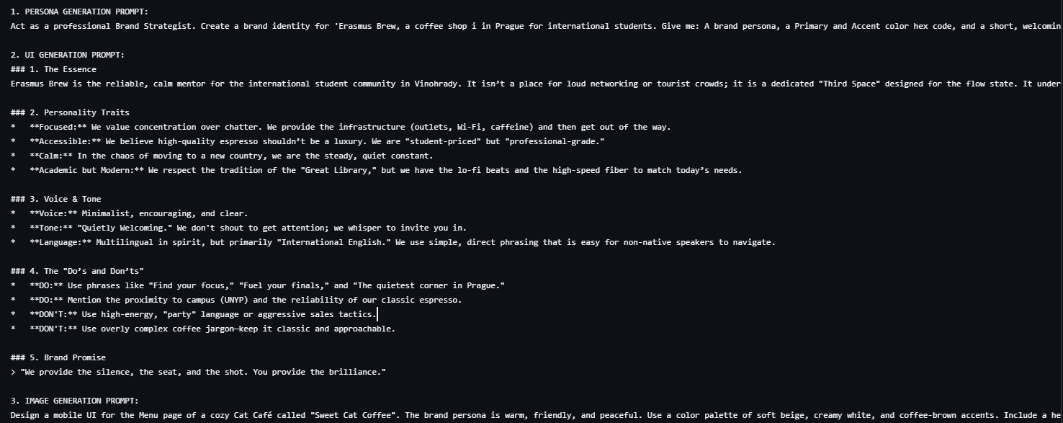

My before:
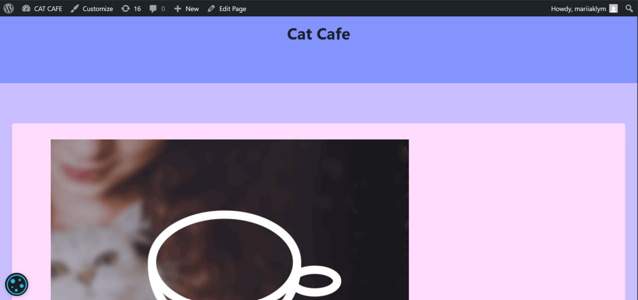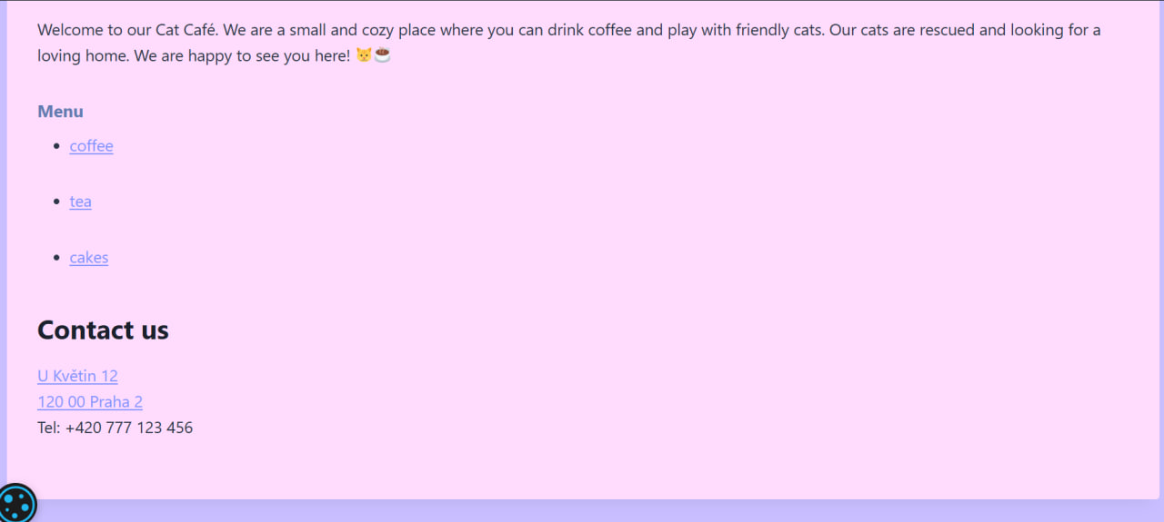My after:
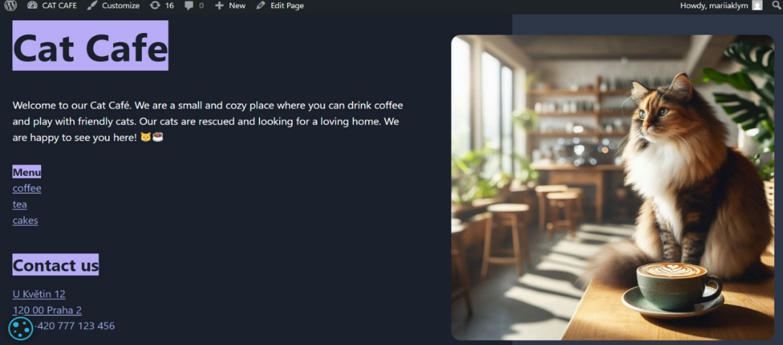
Week 07
Lead Generation & Performance Audit
Transformed the site into a conversion-focused platform by implementing a GDPR-compliant "Brew Crew" loyalty form using WPForms and optimized mobile performance through high-level Lighthouse audits and WebP image compression.
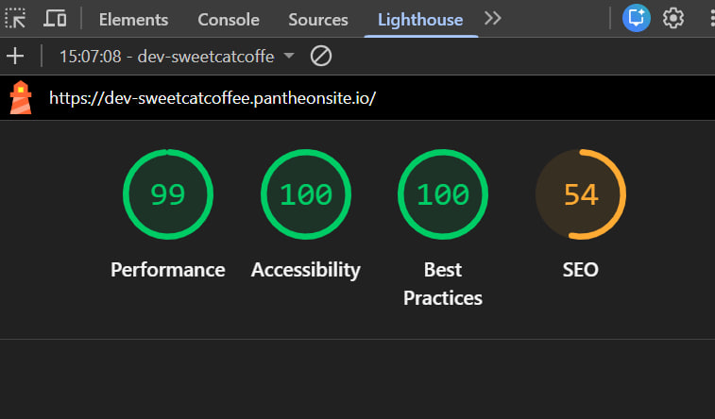

Week 08
The Visibility Layer (Search & Social)
Established a professional digital presence by configuring RankMath Open Graph tags for social media "link cards," optimizing search engine snippets with targeted keywords, and generating a XML sitemap to ensure proper indexing and structural clarity for search engine crawlers.
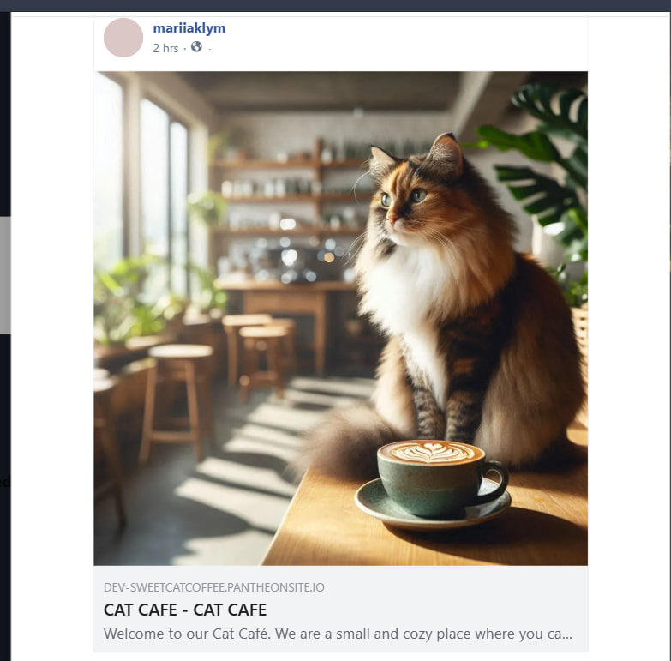

Week 09
The Transaction Layer (E-Commerce Basics)
Transformed the website into a functional digital storefront by integrating WooCommerce, configuring a local-pickup checkout system, and managing a product catalog featuring variable attributes and automated inventory tracking. 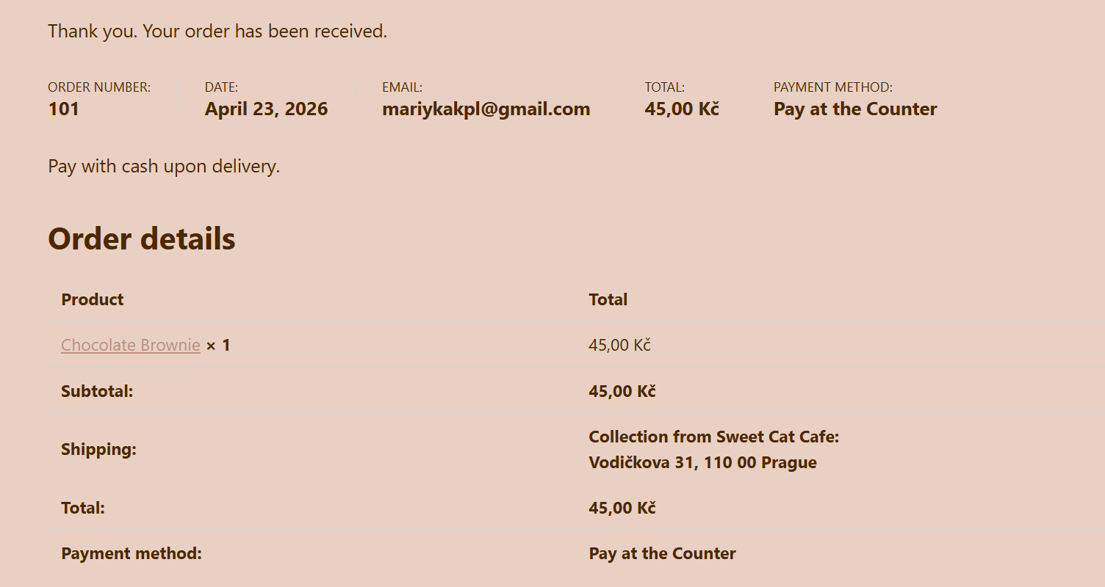
It takes about 5 clicks to complete an order. By using the 'All Products' block on a single page and removing complex shipping steps, we made the process fast for students.
My variable product is the Latte. I gave users the option to choose their Milk Type. The options include Cow milk (standard), Oat milk (+15 CZK), and Soy milk. This allows the business to cater to different dietary needs and charge a premium for plant-based alternatives.
After placing the test order, the stock level for the Brownie automatically decreased from 5 to 4. The product page now reflects this real-time availability, preventing the shop from overselling a limited item.

Week 10
Retention, Loyalty & Maintenance
Finalized the business lifecycle by deploying an automated MailPoet loyalty funnel with personalized "Brew Crew" welcome sequences and a 15% discount strategy, while securing the entire project infrastructure through comprehensive UpdraftPlus manual backups.
The Coupon: FRESHME26 (15% off). The business logic is to reduce friction for first-time student customers and build long-term loyalty.
A Welcome Email designed with a professional, dark aesthetic similar to the Café Savoy style.
I will use "Favorite Cake" data for targeted marketing. For example, if a user prefers Brauni, I will email them specifically about new taste of this cake alternative
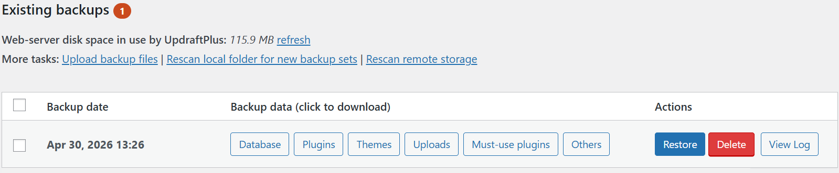

Course Summary
Over the past 10 weeks, I have evolved from manual HTML/CSS coding to managing a complete digital business. By building the Sweet Cat Cafe, I mastered the full stack of modern web management: from AI-driven UI design and SEO optimization to WooCommerce e-commerce and automated marketing funnels. The result is a professional, secure, and data-driven platform that balances high-end aesthetics with technical performance.
Thank you for an incredible semester. I truly appreciate your guidance in helping me bridge the gap between creative concepts and real-world technical execution. Thank you for making these complex systems accessible and for a great learning experience!

